Name : Patel Bhargav Ghanshyambhai

DAY 1 DATE 25/05/2021

TASK

* MAKE REGISTRATION FORM WITH HTML
* 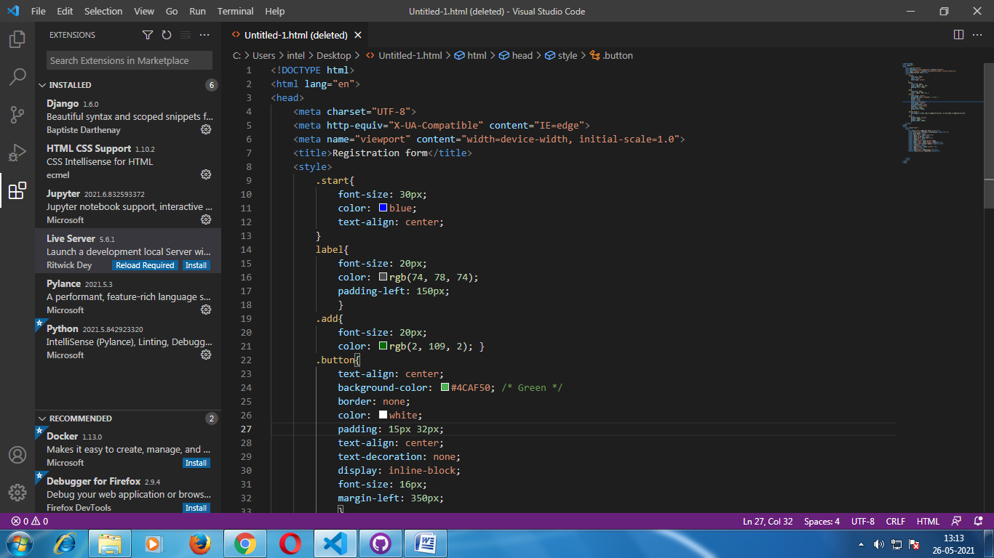DIV/TABLE BASED SMALL WEBSITE

